Pueblo People Vocabulary: Create the vocabulary four squares into your notes with the following words:
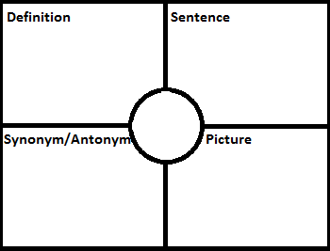
- Adobe- a building material by mixing water with a soil mixture of clay and sand
- Kachinas- the spirits of their ancestors and messenger of the gods and central to the pueblo religion
- Crop rotation- changed what was growing in a certain section of soil yearly.
- Dry farming- a type of farming technique used in areas without a lot of water. Planted seeds deep in the earth to help maintain moisture
- Clan- a group of people related to each other, either based on the mother (matrilineal) or father (patrilineal) includes all extended family members
- Nuclear family- a couple (parent) and their dependent children
- Extended family-a family that extends beyond the nuclear family includes grandparents, uncles, aunts, cousins, and other relatives
- Moiety- two equal parts. Some western pueblos base their workloads on Moieties not clans.

